FREEDOM OF INFORMATION GUIDE

Hudson Area Public Library District

Posted in accordance with 5 ILCS 140/4.

ABOUT HUDSON AREA PUBLIC LIBRARY DISTRICT
Established as a volunteer library by members of The Hudson Junior Woman’s Club in 1980, the predecessor to the Hudson Area Public Library existed without direct tax support.
The Hudson Area Public Library District (HAPLD) was established as a result of a citizen referendum in Hudson, Hudson Township, parts of Money Creek and Unincorporated Normal Township. The vote was held on March 17, 1992, and the question was approved by a nearly 70% vote. On May 12, 1992 the Hudson Area Public Library District became officially established.
HAPLD serves a community of 3,400 residents, as well as reciprocal borrowers within the Resource Sharing Alliance consortium, along with any and all visitors.
We are required to report and be answerable to: Illinois State Library, Springfield, Illinois. Its members are: State Librarian Alexi Giannoulias, Director of the State Library, and various other staff.

OUR MISSION
Through the power of reading, we inspire curiosity, build community, preserve history, and enrich lives.

LIBRARY WEBSITE
https://www.hudsonarealibrary.com

GENERAL FUND OPERATING BUDGET
The fiscal year budget for 2026-2027 is $343,500. The most current Budget and Appropriations Ordinance and Levy Ordinance are available to view in person at the library or digitally by calling the library at (309) 726-1103 to request a copy by email.

HUDSON AREA PUBLIC LIBRARY DISTRICT OFFICE
The administrative office of HAPLD is located in the library’s building at: 104 W. Pearl St., Hudson, IL 61748. The library’s mailing address is: PO Box 461, Hudson, IL 61748. The library has only one branch.

HUDSON AREA PUBLIC LIBRARY DISTRICT STAFF
When fully staffed, the library employs 3 full time employees and 6 part time employees within the structure below:
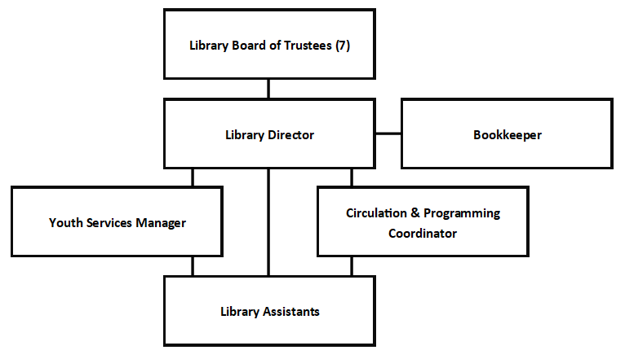

HUDSON AREA PUBLIC LIBRARY DISTRICT BOARD OF TRUSTEES
HAPLD is governed by an unpaid seven-member board of elected trustees.
Open business meetings are held on the second Tuesday of each month at 6:30 pm in the library’s community room.

FREEDOM OF INFORMATION ACT
HAPLD adheres to the Freedom of Information Act, 5 ILCS 140/1 et. Seq., which is the principal Illinois statute governing the inspection of public records. The Act requires that public bodies make available for inspection or copying all public records to any person.

HUDSON AREA PUBLIC LIBRARY DISTRICT FOIA OFFICER
Library Director: Jenny Losey (hudsonarealibrary@yahoo.com)

FILING A FOIA REQUEST
A request for records must be made in writing and can be submitted to the attention of the FOIA officer in the following ways:
By mail: Hudson Area Public Library District
Attn: FOIA Officer
PO Box 461
Hudson, IL 61748

By email: hudsonarealibrary@yahoo.com
Please put FOIA in the subject line of the email

In person: 104 W. Pearl St.
Hudson, IL 61748
During regular library hours

FREEDOM OF INFORMATION ACT REQUEST FEES
Digital copies shareable via electronic means are provided free of charge.
The charge for physical copies of the records will be as follows:
- First 50 pages black and white, letter-size: Free
- 10 cents per page for black and white, letter-size, after 50 pages
- 50 cents per page for color or oversized copies or electronic media
- Reproduction saved to other media: actual cost of the recording media (flash drive, etc.) to which the information will be saved

RESPONSES TO REQUESTS FOR RECORDS
Responses to commercial requests can be expected within 21 business days of the receipt of a written request. If an extension is required, a FOIA officer from the library will reach out to the requestor.
Responses for non-commercial requests can be expected within 5 business days of the receipt of a written request. If an extension is required, a FOIA officer from the library will reach out to the requestor.

RECORDS IMMEDIATELY AVAILABLE UPON REQUEST
The following records are available to view on the library’s website (https://hudsonarealibrary.com):
Board of Trustee Meeting Minutes (July 2023 to present)
Meeting Agendas (most recent)

RECORDS KEPT AT HUDSON AREA PUBLIC LIBRARY DISTRICT
Below is a non-exhaustive list that includes basic categories or records that are available to the public. HAPLD retains records in compliance with the Illinois Local Records Act (50 ILCS 205) and the library’s Records Retention Schedule.
- Accounting Records
- Annual Reports
- Bid Documents
- Board Meeting Agendas
- Board Meeting Minutes
- Board Packets
- Budgets
- Grants
- Job Descriptions
- Legal Notices
- Monthly Financial Statements
- Newsletters
- Ordinances
- Policies

